**Task 01: What is wrong with dog.png. Hint Cyberchef**

Ans:

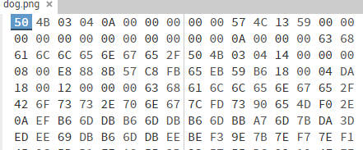

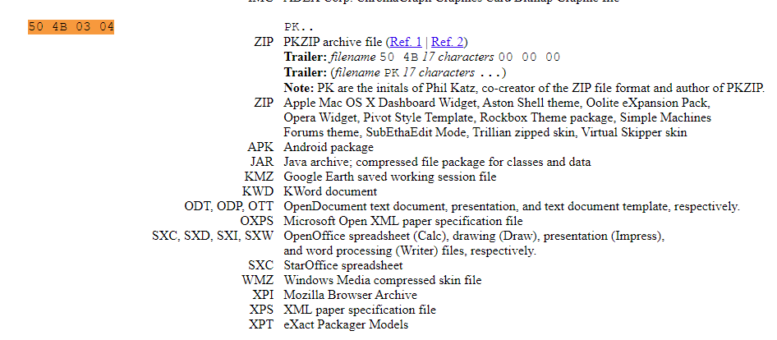



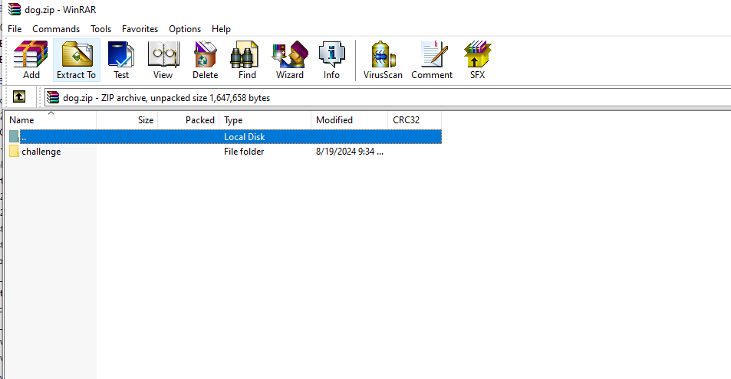

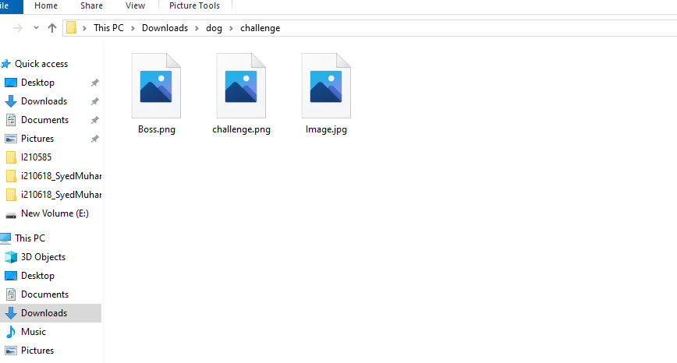

I have gone to the link sir provided, and I searched the file magic bytes, and saw it matched with .Zip file, and I changed the extension to .zip, and yes it opened, and had three files inside of it.

Its extension was out of place.

**Task 02: Can you check Image.jpg and recover the file. Flag format FLAG{text_in_image}. Hint:**

**Check for magic bytes in hexed and match them with jpg magic bytes on Gary Kessler’s site.**

**Ans:**

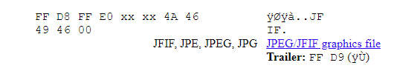



Flag{

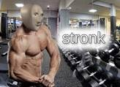

}

Now I searched the magic bytes of file 2, and it was of jpeg, and the file also had written JFIF on side, so I went to the link, and edited the file magic bytes, saved it, and here it was a pic of stronk.

**Task 03: Does changing the extension change magic bytes of the file. Try and add screenshots with**

**explanation.**

**Ans:**

No, it does not change the magic bytes, and by changing magic bytes it does not change the extension aswell.

**Task 04: Can you recover the challenge.png file. Flag format flag{}.**

**Ans:**

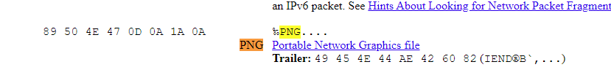

Same as above task, I just changed the magic bytes and it was of PNG, changed it, and here it was , There was NG, in the header so I guessed it would be png.

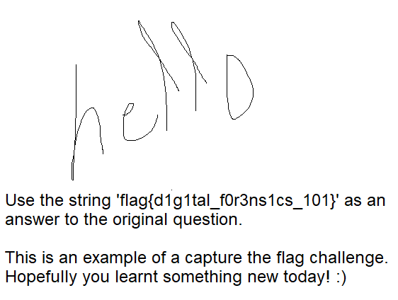

Flag{d1g1tal_f0r3ns1cs_101}

**Task 05: What if magic bytes are totally out of place, how can we check for file type? Hint:**

**“I have wheels, yet I&#39;m not a car.**

**I am big, but I&#39;m not a star.**

**Pull me along, I&#39;ll carry your load.**

**Inside me, stories are often showed.”**

**Ans:**

Trailer bytes, they are on the end of file, and we can use that to detect which type of file it is.

**Task 06 [Bonus]: Can you recover Boss.png?**

**Ans:**

Aass